*Minimax 10 Experiments :*

**First Experiment :**

**Who Plays First : User**

**Strings : 15**

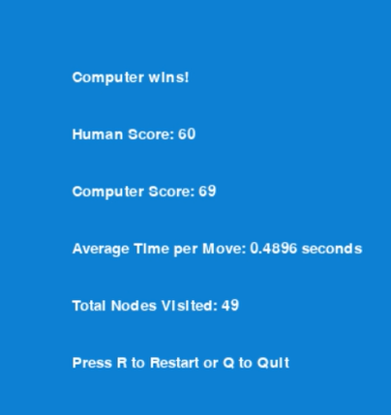

**Second Experiment :**

**Who Plays First : Computer**

**Strings : 16**

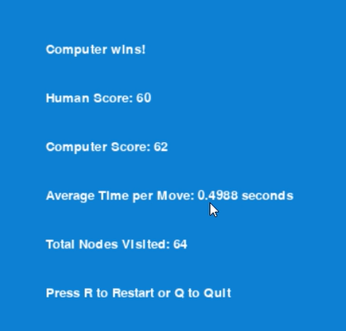

**Third Experiment :**

**Who Plays First : User**

**Strings : 17**

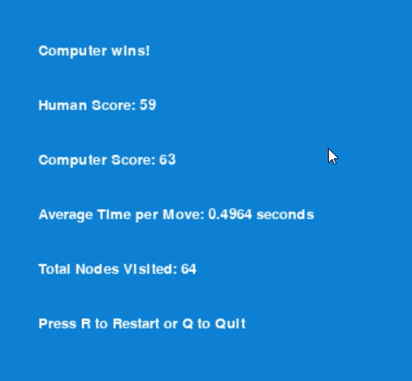

**Fourth Experiment :**

**Who Plays First : User**

**Strings : 19**

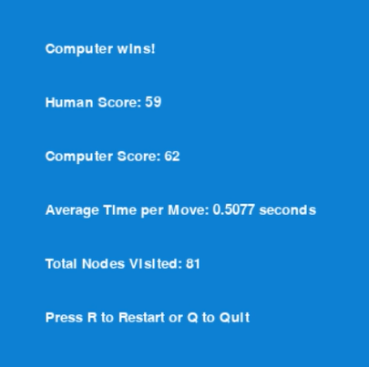

**Fifth Experiment :**

**Who Plays First : User**

**Strings : 18**

**Sixth Experiment :**

**Who Plays First : Computer**

**Strings : 20**

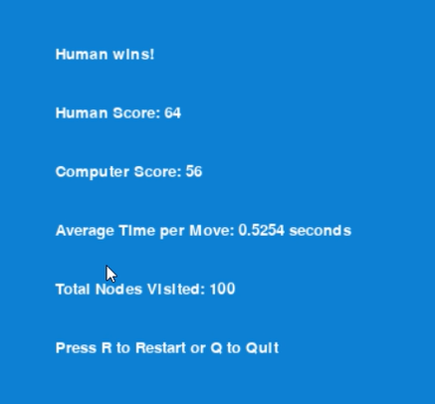

**Seventh Experiment :**

**Who Plays First : User**

**Strings : 21**

**Eightth Experiment :**

**Who Plays First : User**

**Strings : 22**

**Ninth Experiment :**

**Who Plays First : Computer**

**Strings : 22**

**Tenth Experiment :**

**Who Plays First : User**

**Strings : 23**

**Eleventh Experiment :**

**Who Plays First : User**

**Strings : 24**

